

Blackjack Coach

Submitted by:

Keaton Shelton and Johnathon Longmire

Fall 2020

Department of Electrical and Computer Engineering

Tennessee Technological University, Cookeville, TN 38505 USA

*Submitted to Dr. J.W. Bruce in partial fulfillment of the requirements of*

*ECE 2110 Introduction to Digital Systems*

1. Introduction

We used what we learned in class to lay the framework for the design. The motivation behind the design was to create most efficient and functional Blackjack coaching machine. We used the techniques learned in class to complete the sequential part of the design, then used truth tables and Boolean properties to complete the combinational sections. The significance of this machine allows novice Blackjack players to improve their strategy in a game.

The introduction should include subsections:

1.1 The problem addressed in the project is designing a machine to coach a novice gambler to play the best strategy against the “house” in a traditional game of single-deck Blackjack.

1.2 The objective of the machine is to implement the best strategy for the novice gambler to compete against the “house” in the Blackjack game. You want to be able to show the player what their next move could be due to the outcome of what cards are dealt to both the player and the dealer.

1.3 Background knowledge needed would be to know digital systems and the logic needed to implement in the system. Knowing the game of Blackjack helps as well because all of the rules involved in it determined how the design was made to best suit the needs of the novice gambler.

1.4 The adopted approach chosen for the project was to take it a system at a time and to incorporate it into the bigger part. The process was to look at where a problem could arise and then to solve it and make sure lines were connected. With each part going in and implemented, the design would grow, become more complex, and solve more issues.

2. Methods

We worked together the entire time while assembling the circuit and the logic that powers it. We used to the techniques we learned in ECE2110 to implement our design. We both tag teamed each section together to complete it in small sections.

Include any relevant equations and algorithms.

Some important projects aspects that need to be addressed in the project reports are:

a. One problem we discovered was the machine was taking more than five inputs and would over wright the oldest card. We solved this issue by using a series of D-Flip Flops to keep track of the number of cards inputted and if the last one became high the inverse output would flip off telling the input system to not allow any more inputs.

b. Time constraints involved would be class and work scheduling. Monday through Thursday worked fine for us, but other days either had work on them or other classes. Plus, there are other projects for classes and meeting for this project had to be in sync with them.

c. With the knowledge and experience this class provided we were able to design this project.

d. We used the software tool Digital to implement our design. The standards we followed were the rules of Boolean algebra and sequential logic.

e. For the design of this project we didn’t have any regulatory issues that hindered our design.

f. We did not deal with any technological limitations in the design of this circuit.

3. Product Architecture

The architecture design takes a row of inputs for the dealer and the player. The machine can only take one card for the dealer and up to 5 for the player. It takes the cards on the player line and moves them in series across a bank of D-Flip Flops. The values are then read from the banks into comparators and into adders. There are checks in place to prevent the comparators from detecting a false positive of 0 = 0. If the comparators detect a valid match it completely overrides the output from the hard and soft tables and replaces it with its output. If no match is detected then the values from the adders and the dealer cards are read into the circuitry for the hard and soft values and returns the output. The two seven segment displays are powered directly by the five bit value read from the adders. We are confident that our design is upheld to the highest standards.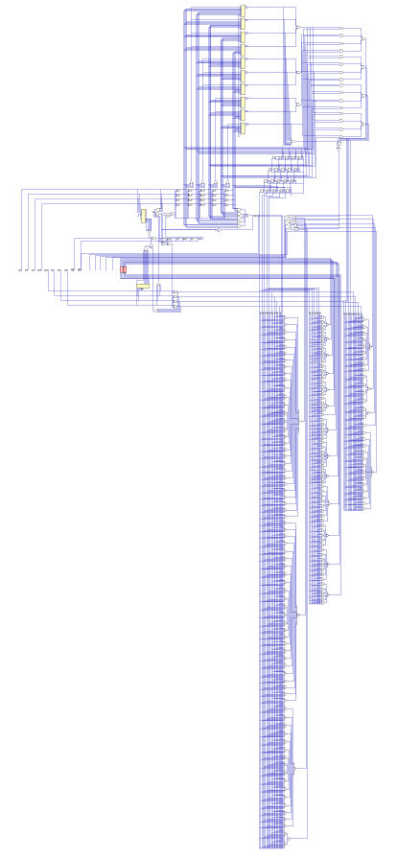

3.1 Product Subsystems (3.2, 3.3, 3.4, etc as needed)

The inputs for the player are stored in series on five banks to hold five values. The dealer only has one bank for one value. The comparators first detect if anything is held in the bank, if so equivalent comparator will power on. Once a matching comparator set is found it then pulls the values through a series of checks and outputs them to the split logic. The adders pull the values from the player banks in real time and updates accordingly. Those values are then immediately passed to the hard and soft logic as well as the seven segment logic. The hard and soft logic takes the player total as an input as well as the dealer value and returns the output. The split logic takes the output of the comparator logic as well as the dealer value and returns an output the always overrides the value of the hard and soft logic. The seven segment display takes the five bit value returned by the adders as input and returns its output into the two seven segment displays.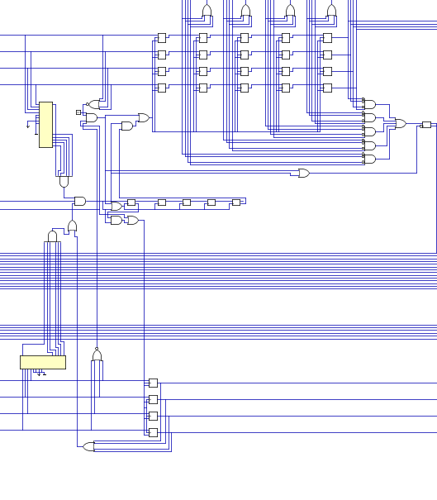

Input Logic ^

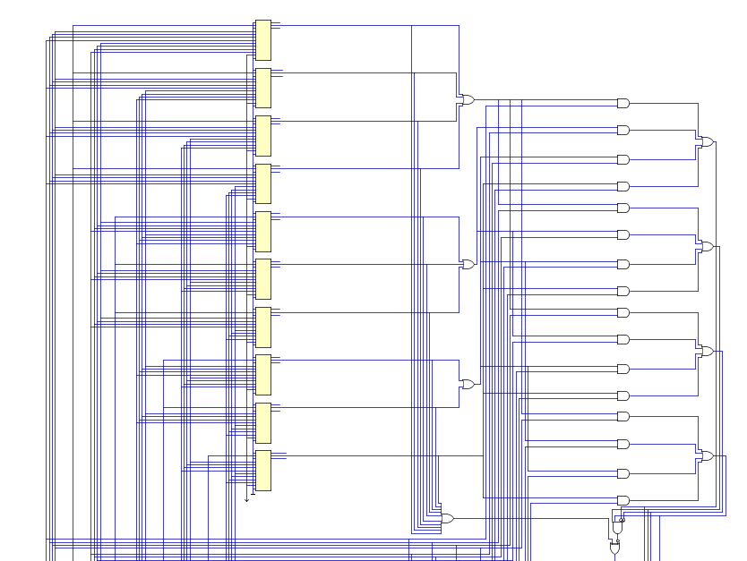

Comparator Logic ^

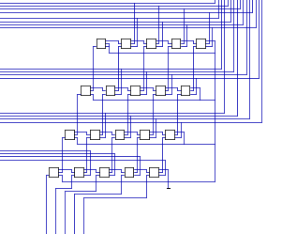

Adder Logic ^

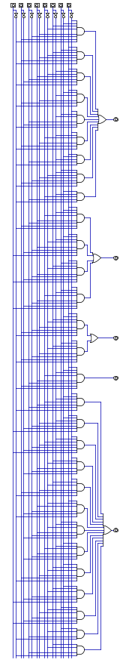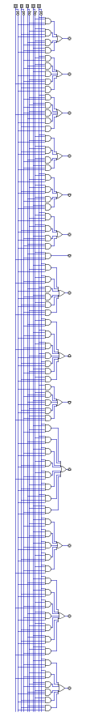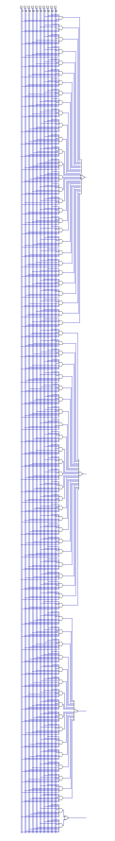

Split logic 7 Segment logic Hard and soft logic

4. Testing and Product Verification Results

We tested many different scenarios but we’ll highlight a case from each scenario. With the first case being a hard total of eight and a dealer card of five. For case two we’ll have a soft total of thirteen and a dealer card of four. For case three well have a split of two and a dealer card of two.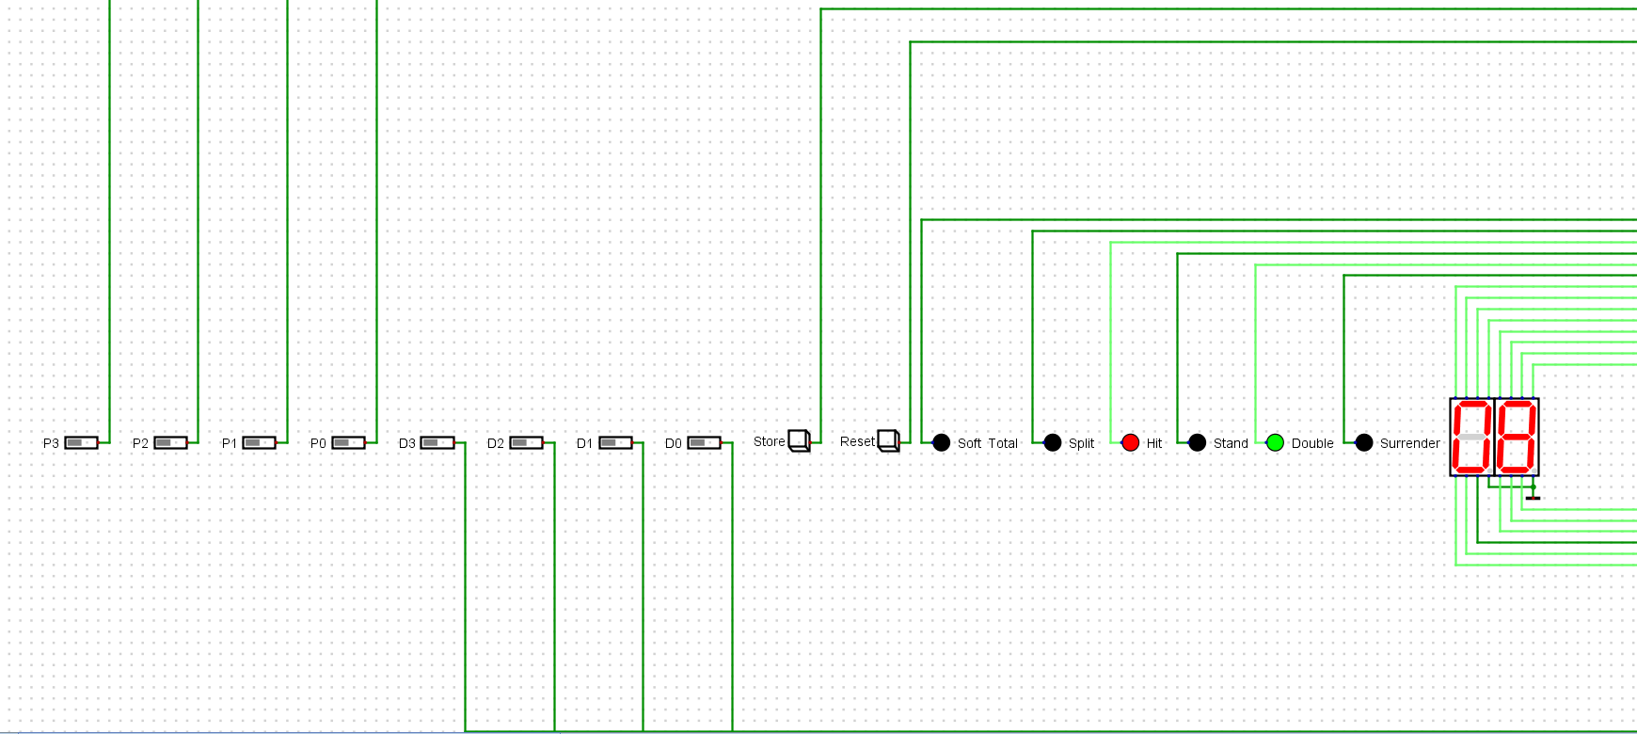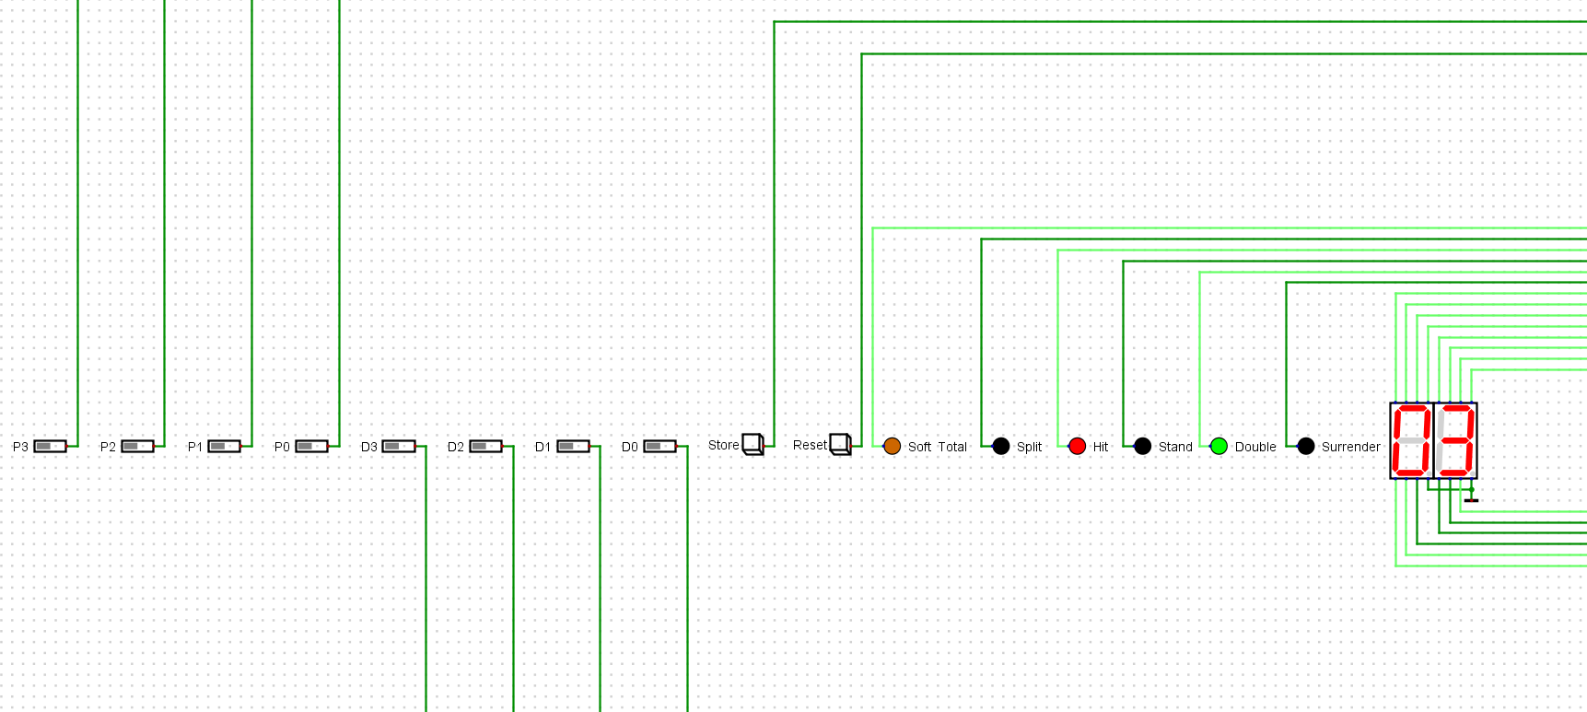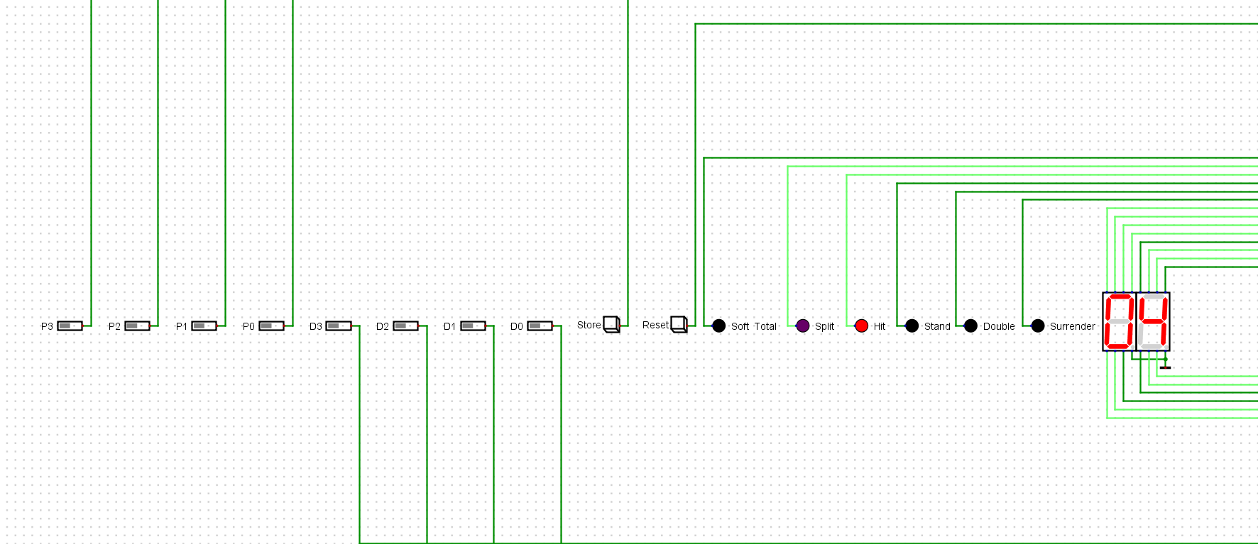

5. Cost and Sustainability Analysis

Sustainability consideration and constraints includes economic, environmental, and social aspects that need to be evaluated and considered in project research and development. There is a strong relationship between these three pillars of sustainability. These need to be considered and incorporated in this section with a discussion on their design constraint and the positive and negative effects of the project within this scope. Beyond the feasibility of the technical solution, an engineering project needs to take into account the following aspects (as appropriate):

1. Economics (cost) impact: should consider, when relevant,

|  |  |  |  |
| --- | --- | --- | --- |
| Gates | Amount | Cost Per Unit | Totals |
| NOT | 22 | $0.02 | $0.44 |
| NAND/NOR | 202 | $0.03 | $6.06 |
| NN IN | 648 | $0.01 | $6.48 |
| S GATES | 383 | $0.05 | $19.15 |
| S IN | 1651 | $0.01 | $16.51 |
| FF | 30 | $0.15 | $4.50 |
| BUTTON | 10 | $1.00 | $10.00 |
| LED | 6 | $0.85 | $5.10 |
| 7-SEG | 2 | $1.50 | $3.00 |
| MEM | 0 | $0.10 | $0.00 |
| MEM IN | 0 | $0.05 | $0.00 |
| Hours | 25 | $75 | $1,875.00 |
| Final Total: |  |  | $1,946.24 |

* No energy savings or tax incentives apply to this circuit.
* Materials that are used in the production of this circuit is widely available.

b. Environmental impact of the product: when relevant, please consider

* The product designed here would not specifically emit greenhouse gases, but through the great pyramid of business, the pieces must come from somewhere. Components or any little piece from which a part is obtained from would require power and that itself would involve consumption of power and the emission of greenhouse gases.
* This product would not affect the environment with usage of water, food, or wood. Electrical items do use power so the item would consume its own power.
* The resources needed for the design would not require precious material. The pieces and logic needed are available and online to order.
* Natural resources to build this design are already under operation. The best move with this is choosing where to get the materials that best fit our needs and keep the item cost-efficient.
* The design does not hold back or cross any environmental regulations. The process to get it to us, for example the collecting of resources, would be the ones dealing with that issue. A design like this would not bring any red flags to the market for breaking an environmental rule.

c. Social impact of the product: when relevant, please consider

* The developed product would impact a person’s life if they decided to have an interest in single-deck Blackjack. It would show them what is happening and could maybe follow the patterns that may show. Blackjack could be positive or negative on a person’s life depending on addiction and whether they win enough to make a difference in their life. The odds are against a novice player, but following a design and procedure would be their best chance at making an impact on their life.
* The designed product would mainly be an interest to an individual that is new to the game of single-deck Blackjack. It could be something they follow and learn to pick up on details on what to do in certain aspects of the game.
* With the product and an understanding of Blackjack, more people could look forward to playing it. Whether looking to have a good time or gamble on a game, people in the world are always looking for a new hobby or ability to add to their life. A product like this could make them look more into Blackjack and learning the game.
* The project design is to make it easier on the player. Players of the game have to know what to do in certain situations that come into while playing Blackjack. The machine presented here gives an outline of numbers and what a possible next move for them could be. No jobs should be lost from the design, it should only enhance a player’s ability to play single-deck Blackjack.
* The product itself would not create a new field, but jobs would of course be created or maintained to assemble the design. People would be needed to create the product and to test the product. Jobs are needed to maintain quality and make sure the device performs to its highest ability.
* Safety aspects or health concerns to be considered would be to not get addicted to the game. The device project does not encourage gambling and it should be noted that the odds are against winning.
* A constraint that could arise in the social world is if the machine is allowed in areas. Many states or regions do not allow gambling with Blackjack. The device would need to be labeled as a way of teaching a novice player how to play single-deck Blackjack.

6. Conclusion

The machine can help a novice player have better strategies when playing Blackjack on the idea that the dealer stands on soft seventeen. The only limitation to this machine is that the soft totals are displayed as if the Ace is a one instead of an eleven. If we had some more time we would add a section to the circuit that artificially raised the total to reflect the true soft total as if an Ace being eleven.

7. Acknowledgments [if applicable]

Keaton Shelton and Johnathon Longmire and Johnathon Longmire.

8. REFERENCES

Bruce, J W. “Fall Project 2020.” *ECE 2110 -- Fall 2020 Project: Blackjack Coach*, 2020, jwbruce.info/teaching/ece2110/fall20/project_f20.html.

Shackleford, Michael. “Single-Deck Blackjack Strategy.” *Wizard of Odds*, Wizard of Odds, 8 Nov. 2020, wizardofodds.com/games/blackjack/strategy/1-deck/.